R Workshop

## R Markdown

This is an R Markdown document. Markdown is a simple formatting syntax for authoring HTML, PDF, and MS Word documents. For more details on using R Markdown see <http://rmarkdown.rstudio.com>.

When you click the **Knit** button a document will be generated that includes both content as well as the output of any embedded R code chunks within the document. You can embed an R code chunk like this:

setwd("/Users/patriciakirkland/Dropbox/Empiprical Reasoning Center/R Workshop")  
  
load("evaluation_data.RData")  
  
head(data)

## minority age female onecredit beauty course_eval intro nnenglish  
## 1 1 36 1 0 0.2899157 4.3 0 0  
## 2 0 59 0 0 -0.7377322 4.5 0 0  
## 3 0 51 0 0 -0.5719836 3.7 0 0  
## 4 0 40 1 0 -0.6779634 4.3 0 0  
## 5 0 31 1 0 1.5097940 4.4 0 0  
## 6 0 62 0 0 0.5885687 4.2 0 0

summary(data)

## minority age female onecredit   
## Min. :0.0000 Min. :29.00 Min. :0.0000 Min. :0.00000   
## 1st Qu.:0.0000 1st Qu.:42.00 1st Qu.:0.0000 1st Qu.:0.00000   
## Median :0.0000 Median :48.00 Median :0.0000 Median :0.00000   
## Mean :0.1382 Mean :48.37 Mean :0.4212 Mean :0.05832   
## 3rd Qu.:0.0000 3rd Qu.:57.00 3rd Qu.:1.0000 3rd Qu.:0.00000   
## Max. :1.0000 Max. :73.00 Max. :1.0000 Max. :1.00000   
## beauty course_eval intro nnenglish   
## Min. :-1.4504940 Min. :2.100 Min. :0.0000 Min. :0.00000   
## 1st Qu.:-0.6562689 1st Qu.:3.600 1st Qu.:0.0000 1st Qu.:0.00000   
## Median :-0.0680143 Median :4.000 Median :0.0000 Median :0.00000   
## Mean : 0.0000001 Mean :3.998 Mean :0.3391 Mean :0.06048   
## 3rd Qu.: 0.5456024 3rd Qu.:4.400 3rd Qu.:1.0000 3rd Qu.:0.00000   
## Max. : 1.9700230 Max. :5.000 Max. :1.0000 Max. :1.00000

## Writing About Data

With R Markdown, we can easily present information about data. For example, we can start with some descriptive statistics. Our main dependent variable of interest is *course evaluation*, which has a mean of 3.998 with a minimum value of 2.1 and a maximum value of 5.

## Including Plots

You can also embed plots, for example:

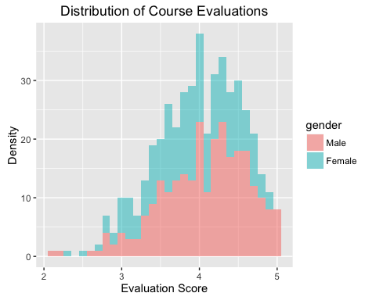

Note that the echo = FALSE parameter was added to the code chunk to prevent printing of the R code that generated the plot.

## Adding Tables

You can also use the stargazer R package (or other R packages, such as kable or xtable) to add tables to documents created with RMarkdown.

### Summary Statistics

Statistic

N

Mean

St. Dev.

Min

Max

minority

463

0.138

0.346

0

1

age

463

48.365

9.803

29

73

female

463

0.421

0.494

0

1

onecredit

463

0.058

0.235

0

1

beauty

463

0.000000

0.789

-1.450

1.970

course_eval

463

3.998

0.555

2.100

5.000

intro

463

0.339

0.474

0

1

nnenglish

463

0.060

0.239

0

1

### Regression Tables

Dependent variable:

course_eval

female

-0.198***

(0.051)

beauty

0.149***

(0.032)

Constant

4.082***

(0.033)

Observations

463

R2

0.066

Adjusted R2

0.062

Residual Std. Error

0.537 (df = 460)

F Statistic

16.331*** (df = 2; 460)

Note:

*p<0.1;* ***p<0.05;*** p<0.01

## Why Use R Markdown?

* easy to include plots and results--- everything in one file!
* the document is replicable
* produces documents in multiple formats
  + PDF (must have LaTeX)
  + HTML
  + MS Word
* also produces beamer or ioslides, which makes it easy to display code, plots, results